Digital Design Diploma

# **Assignment 2**

# **Combinational & Sequential Logic Design**

|  |  |
| --- | --- |
| **Name** | كريم حسن عاطف علي |
| **Group** | G2 |

**Submitted to: Eng. Kareem Waseem**

1. 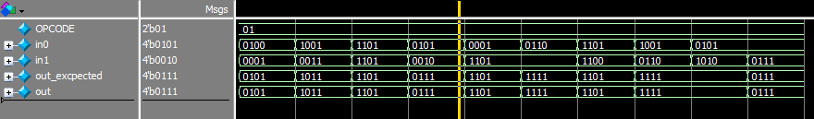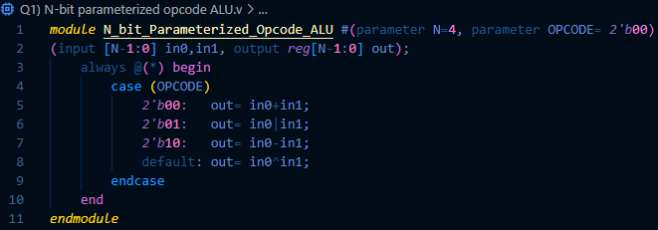**N-bit Parameterized Opcode ALU:**

Figure 2: Q1 Wave (Addition)

Figure 1: Q1 Code

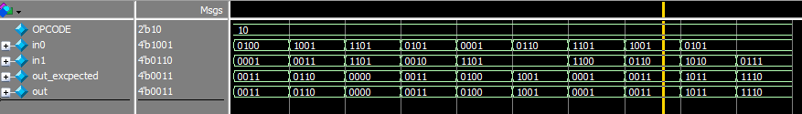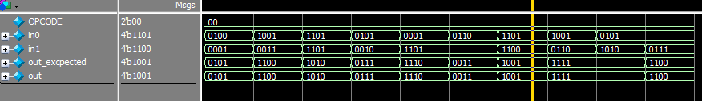

Figure 4: Q1 Wave (Subtraction)

Figure 3: Q1 Wave (OR)

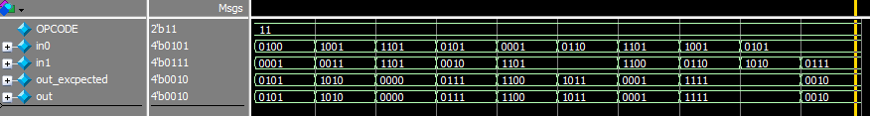

Figure 5: Q1 Wave (XOR)

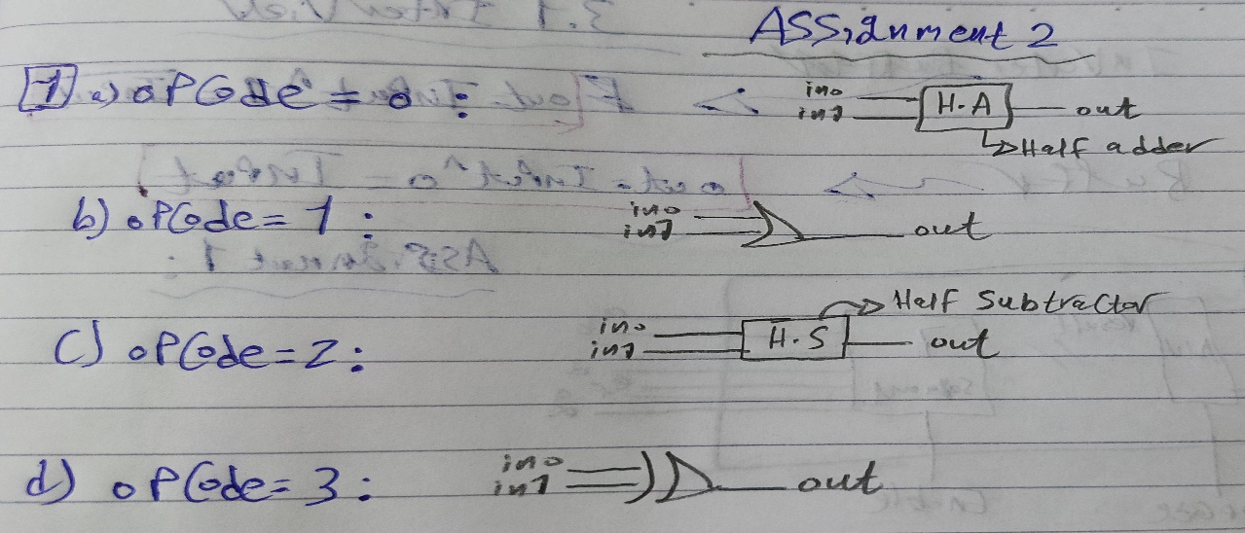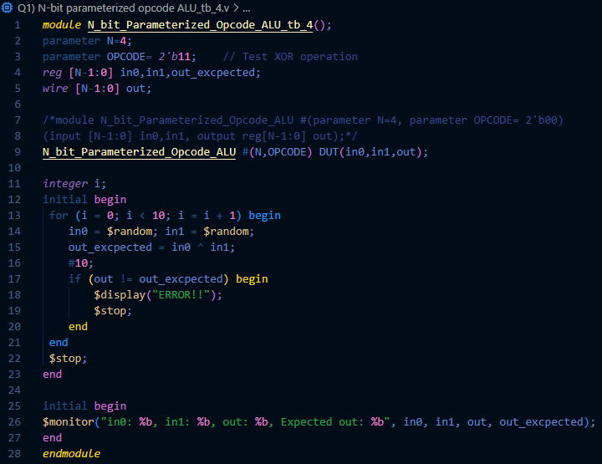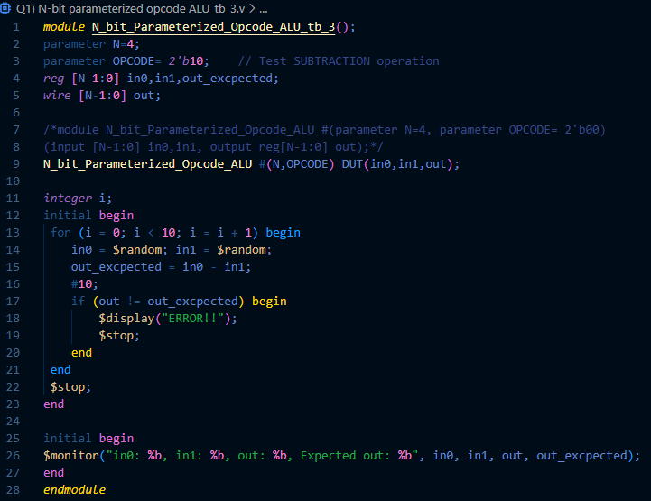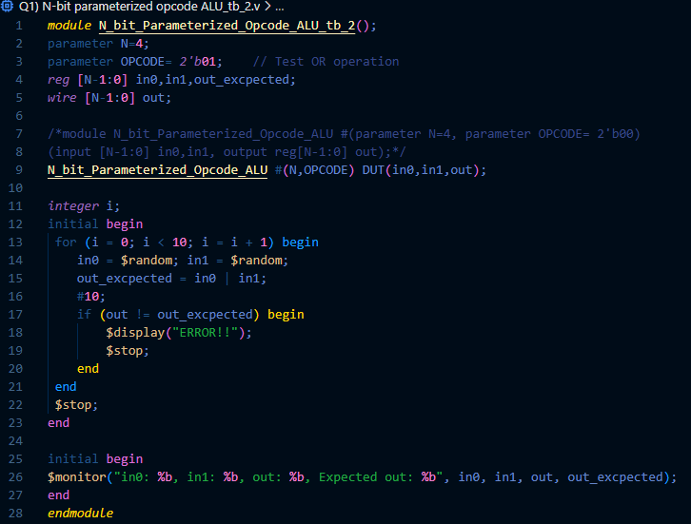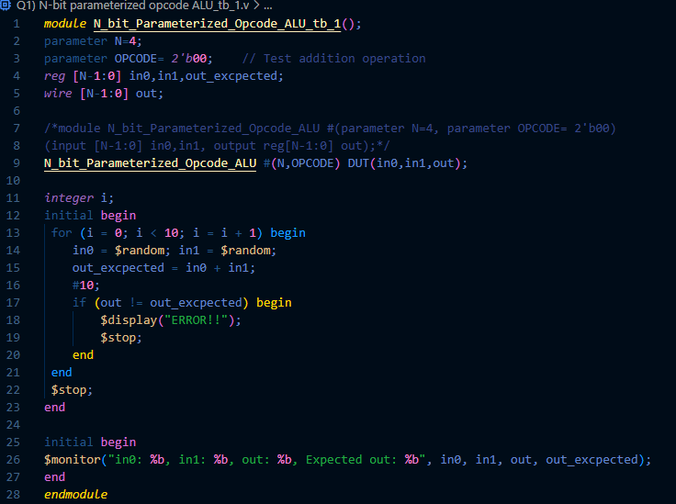

Figure 10: Q1 Synthesis

Figure 8: Q1 testbench (Subtraction)

Figure 9: Q1 testbench (XOR)

Figure 7: Q1 testbench (OR)

Figure 6: Q1 testbench (Addition)

1. 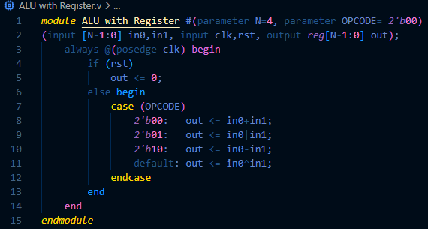**ALU with Register:**

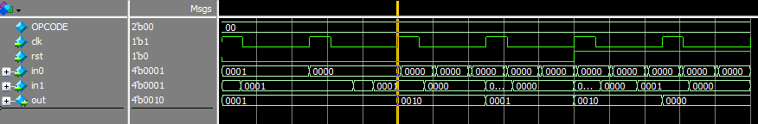 Figure 11: Q2 Code

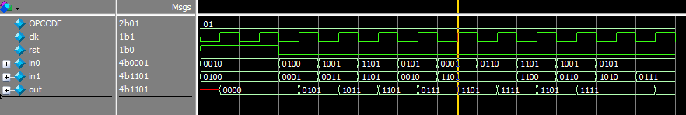 Figure 12: Q2 Wave (Addition)

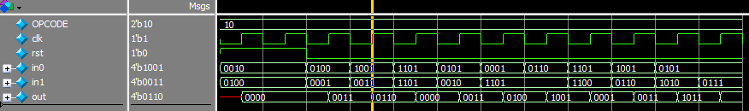 Figure 13: Q2 Wave (OR)

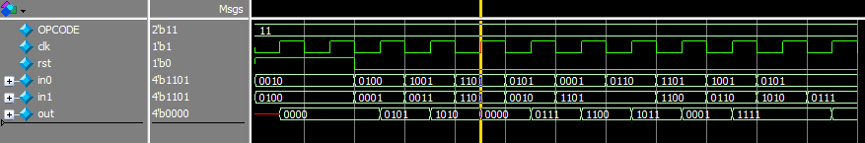 Figure 14: Q2 Wave (Subtraction)

Figure 15: Q2 Wave (XOR)

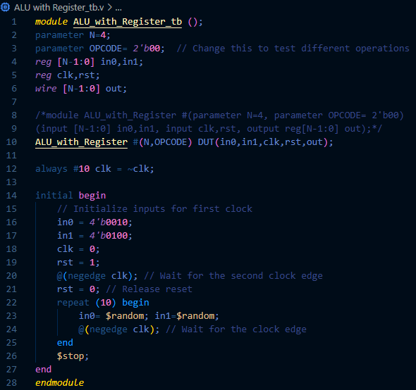

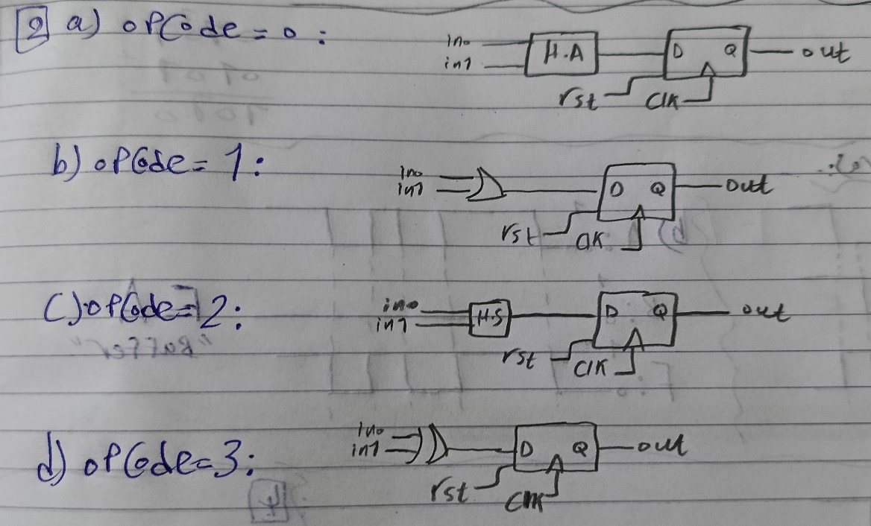

Figure 16: Q2 Testbench

Figure 17: Q2 Synthesis

1. **Data Latch with active low Clear:**

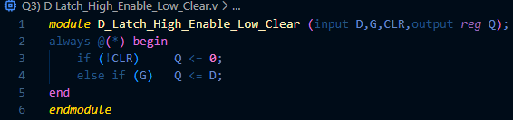

Figure 18: Q3 Code

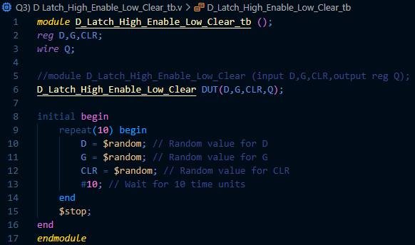

Figure 19: Q3 Testbench

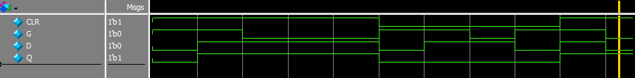

Figure 20: Q3 Wave

1. **D Latch with Asynchronous set and clr:**

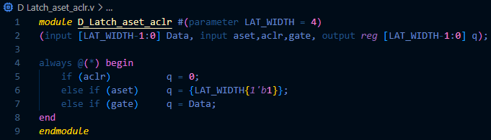

Figure 21: Q4 Code

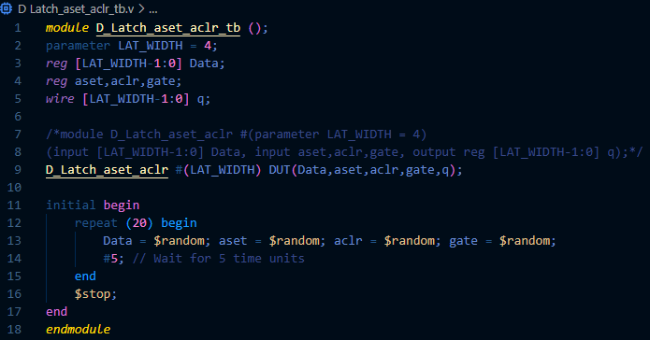

Figure 22: Q4 Testbench

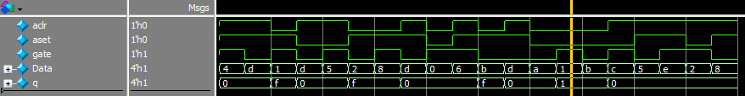

Figure 23: Q4 Wave

1. **T FF with Asynchronous Active Low rst:**

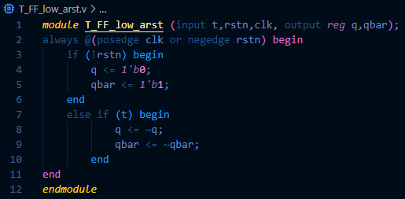

Figure 24: Q5a Code

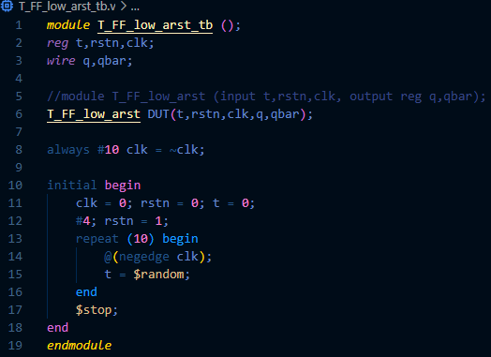

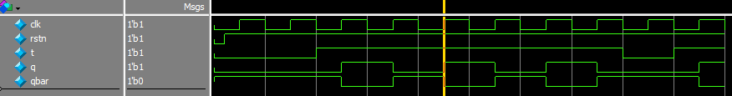

Figure 26: Q5a Wave

Figure 25: Q5a Testbench

1. 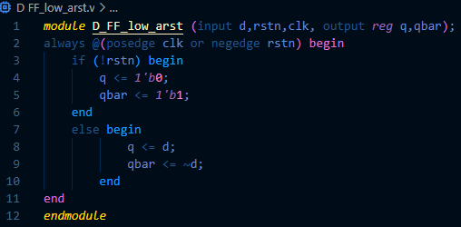**D FF_low_arst:**

Figure 27: Q5b Code

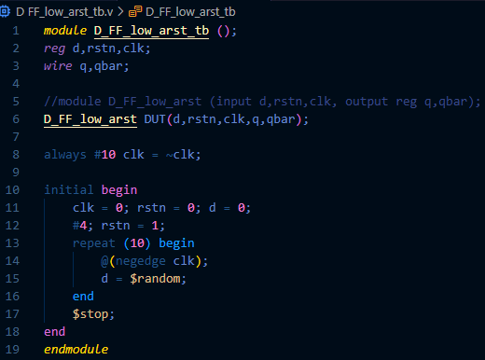

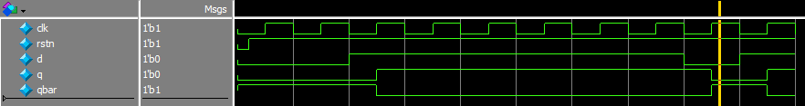

Figure 29: Q5b Wave

Figure 28: Q5b Testbench

1. **Parameterized Asynchronous FF with Active low rst**

**(D FF & T FF):**

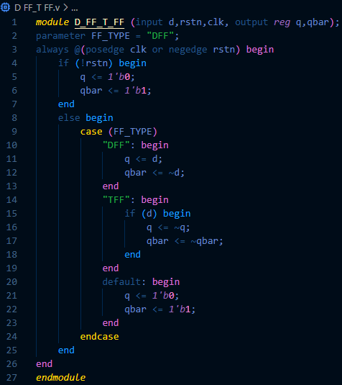

Figure 30: Q5c Code

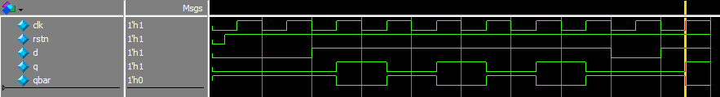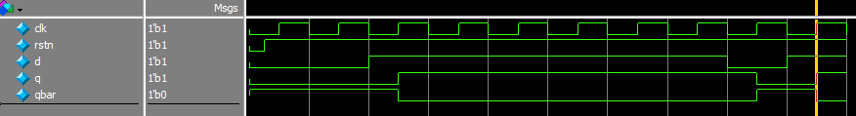

Figure 32: Q5c Wave (TFF)

Figure 31: Q5c Wave (DFF)

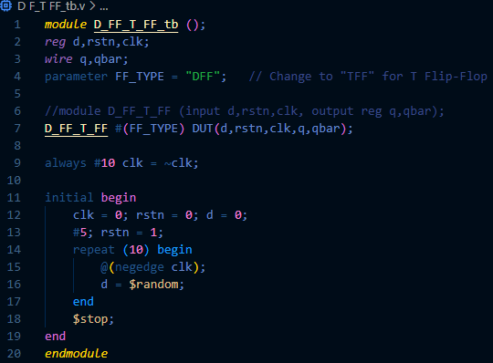

Figure 33: Q5c Testbench